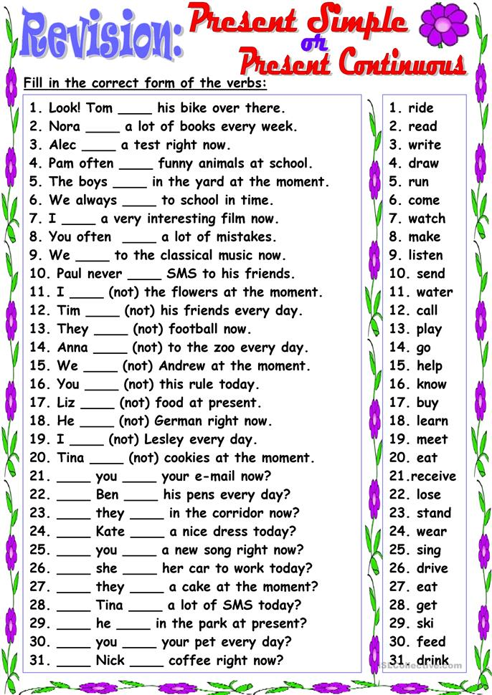
Ibn sina school -6th Grade worksheet

