Odd and out أحط بدائرة حول الكلمة الشاذة

- Red , green , one
- Three , black , ten
- Dog , zero , cat , horse
- Play , read , Sunday , ride
- Swim , Monday , Tuesday , Wednesday
Write sentences أكتب جملا
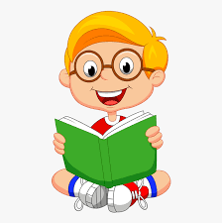
مثال: I read book.


1.________________________________________
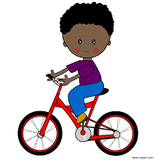
2. ________________________________________
3._________________________________________

