What are the parts that make up a house? Use the words below to help you remember all the rooms in a house. Then write the names in the labels.

**H**

**yard**

**living room**

|  |  |  |  |  |
| --- | --- | --- | --- | --- |
| **dining room** | **bathroom** | **office** | **kitchen** | **bedroom** |

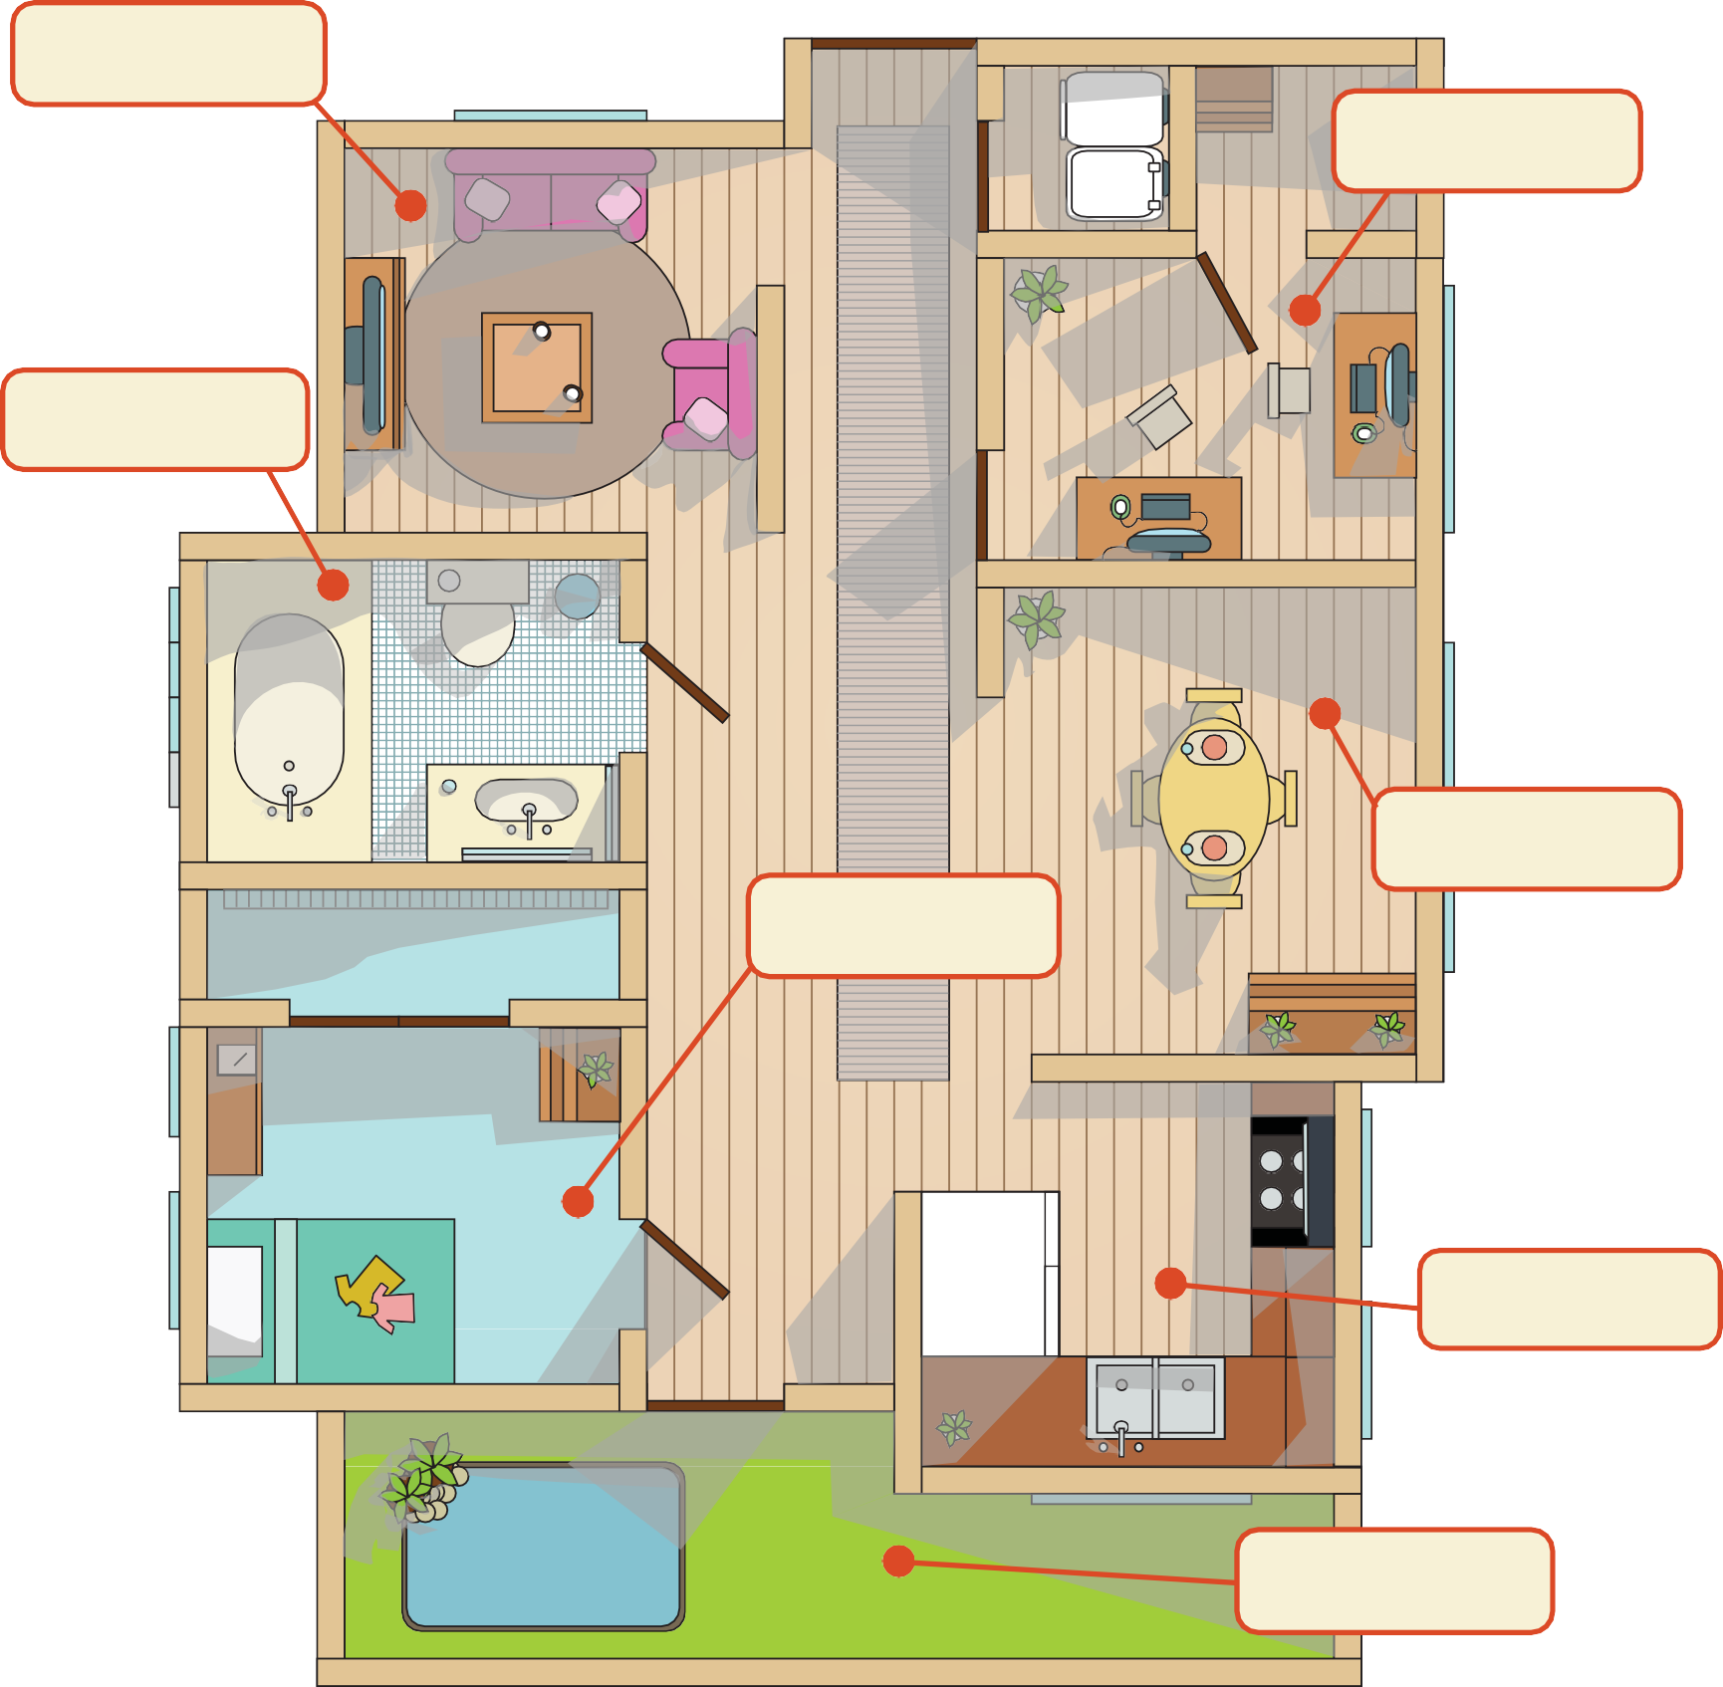

**R**

**o**

Copyright © 2012-2013

2010-2011

by Education.com

More worksheets at [www.education.com/worksheets](http://www.education.com/worksheets)