Ibn Sina school –vocabulary activity

[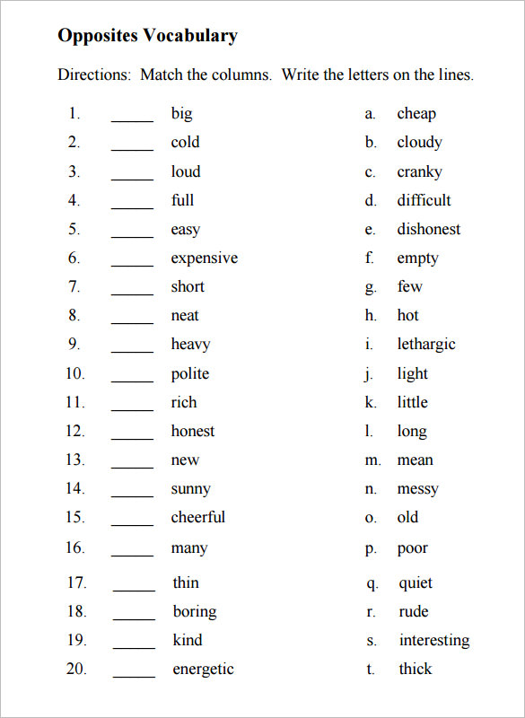](https://www.google.com/url?sa=i&url=https://www.template.net/business/sheet-templates/blank-vocabulary-worksheet-template/&psig=AOvVaw1T0-O3z1GqwT_PApFel8hD&ust=1584602518623000&source=images&cd=vfe&ved=0CAIQjRxqFwoTCLie2cS-o-gCFQAAAAAdAAAAABAD)