Ibn sina school –Read and choose !

[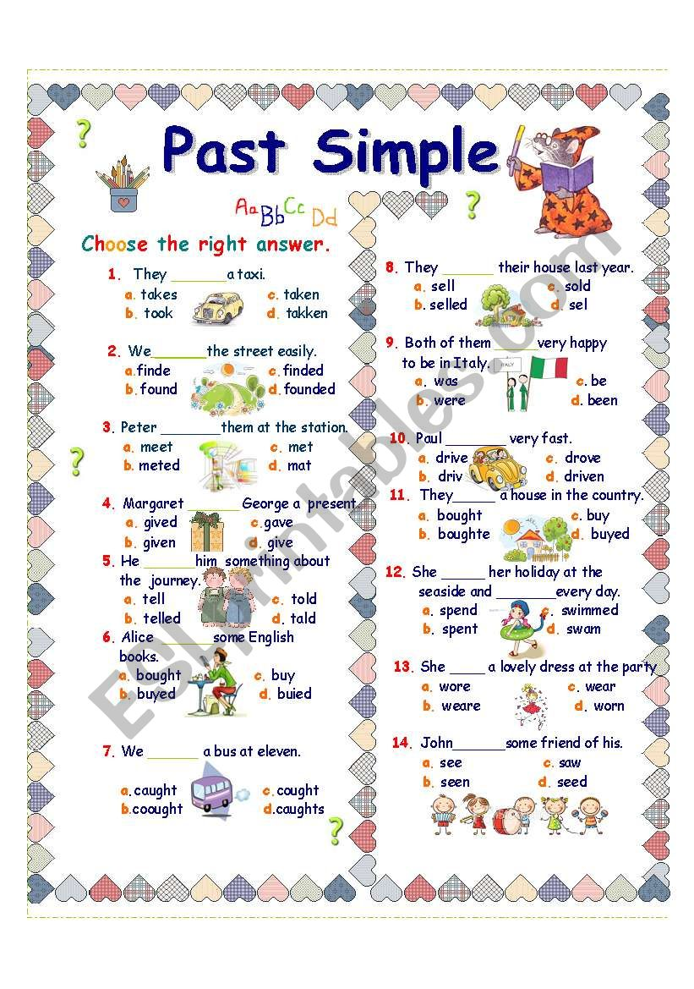](https://www.google.com/url?sa=i&url=https://www.eslprintables.com/grammar_worksheets/verbs/verb_tenses/simple_past_irregular_verbs/PAST_SIMPLE_IRREGULAR_VERBS_255355/&psig=AOvVaw28rrY-Qd18tAGDz5kMwa02&ust=1592414667137000&source=images&cd=vfe&ved=0CAIQjRxqFwoTCMD8pobthuoCFQAAAAAdAAAAABAD)