# Name: Date

**Coloring C Activity Directions: Color the Letter C and Cat**

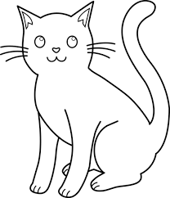

……………………………………………………………………………………………………………………………………………………

………………………………………………………………………………………………………………………………………………………

[**www.englishlinx.com**](http://www.englishlinx.com/)