[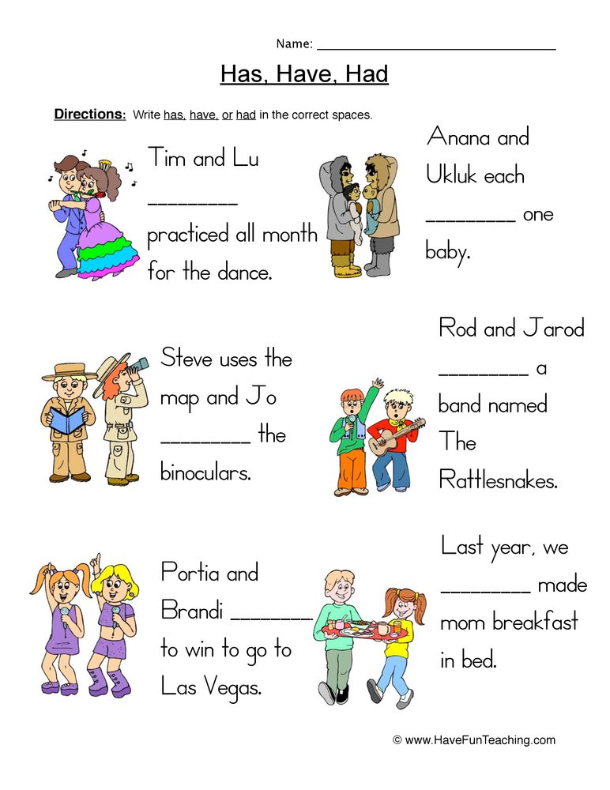](https://www.google.com/url?sa=i&rct=j&q=&esrc=s&source=images&cd=&cad=rja&uact=8&ved=2ahUKEwiZ7c6WnffgAhXQx4UKHXKOAGQQjRx6BAgBEAU&url=/url?sa=i&rct=j&q=&esrc=s&source=images&cd=&ved=&url=https%3A%2F%2Fwww.havefunteaching.com%2Fresources%2Fenglish%2Fverbs%2Fworksheets%2F&psig=AOvVaw0Ph4OrEQoByJ4dMSzX8w02&ust=1552288721552320&psig=AOvVaw0Ph4OrEQoByJ4dMSzX8w02&ust=1552288721552320)