Ibn Sina School-past tense

[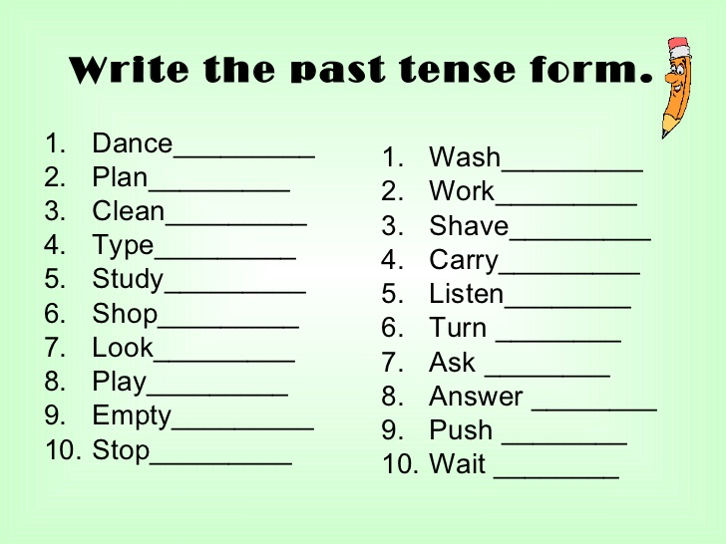](https://www.google.com/url?sa=i&url=https://www.cinemas93.org/past-tense-worksheets-pdf/&psig=AOvVaw2JIt5q55VD3yvad7HAbVU-&ust=1585207543824000&source=images&cd=vfe&ved=0CAIQjRxqFwoTCNjz0LWMtegCFQAAAAAdAAAAABAg)

**Choose five verbs from the list above, write sentences that describe actions that happen usually**

**Write in your notebooks, I will check later on !**

**Good Luck and have safe days**