**Name: Date:**

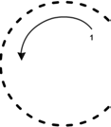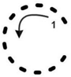

**Tracing Alphabet Activity**

Direction: Trace the letter C Upper Case and c Lower Case with your pencil.

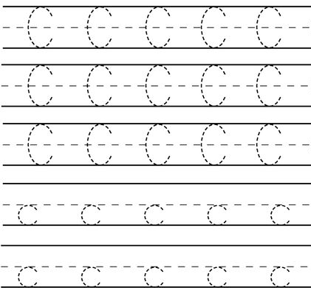

[**www.englishlinx.com**](http://www.englishlinx.com/)