Ibn Sina School –present simple

[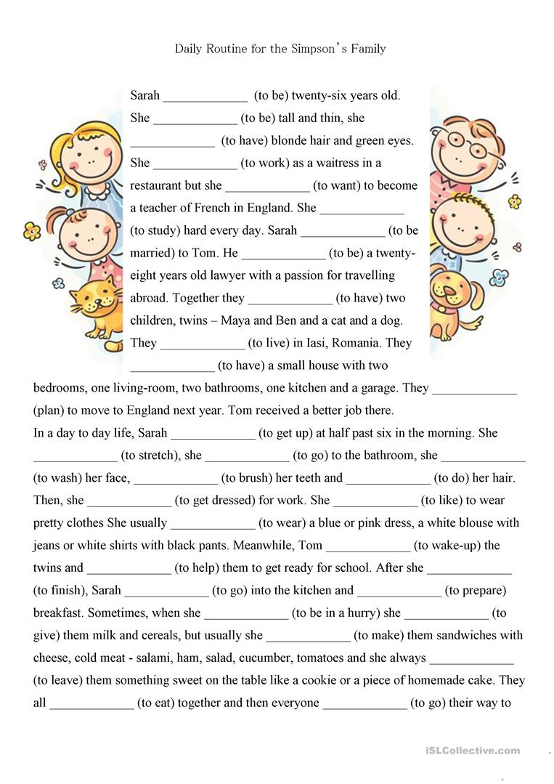](https://www.google.com/url?sa=i&url=https://en.islcollective.com/english-esl-worksheets/grammar/present-simple-tense-s-third-person-singular/4pages-present-simple-reading-comprehension-textexercises-fa/106049&psig=AOvVaw1mlaNx6ySmrq_Zy0kIb_aC&ust=1584352043838000&source=images&cd=vfe&ved=0CAIQjRxqFwoTCODH87iZnOgCFQAAAAAdAAAAABAD)