þÿ

Word:

Alphabet Practice (Letter B)

þÿ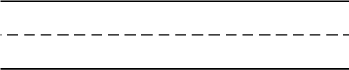Write the letter (B) and (b) five times each.

# B

b

þÿWrite two words that start with the letter (b). Then,

draw a picture with one of the words in the box at the right.



Copyright [www.englishlinx.com](http://www.englishlinx.com/)