**Write the meaning: أكتب المعنى باللغة العربية**

1. Boy: ________
2. Computer:_________
3. Shop: __________
4. Sing: __________
5. Teacher: __________
6. Watch: ___________

**Complete the sentences: أكمل الجمل الاتية**

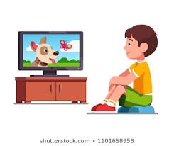

1. I ________ TV.
2. I ________ football.
3. I _________ milk.
4. I write in my __________.
5. This is a ________.