# Name: Date:

Coloring A Activity

# Directions: Color the Letter A and Apple

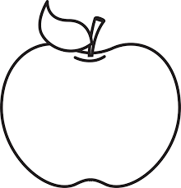

……………………………………………………………………………………………………………………………………………….

………………………………………………………………………………………………………………………………………………….

[**www.englishlinx.com**](http://www.englishlinx.com/)