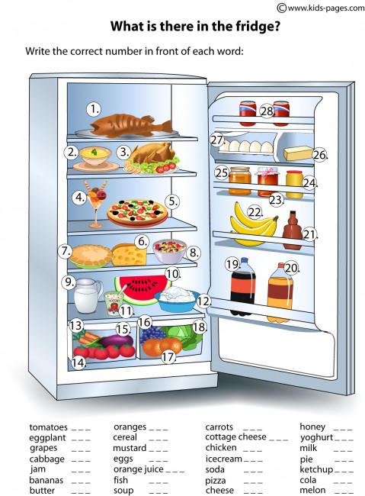

\*write the correct number in front of each word

اكتب الرقم الصحيح للصورة امام كل كلمة

\*write five sentences start with ( there is / there are )

اكتب خمس جمل تبدأ ب there is / there are