[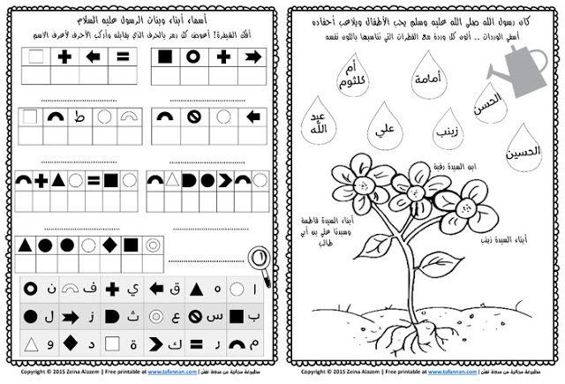](http://www.google.co.il/url?sa=i&rct=j&q=&esrc=s&frm=1&source=images&cd=&cad=rja&uact=8&ved=0ahUKEwjJ7Yqfv9jQAhWErRoKHTOQDbQQjRwIBw&url=http://www.tafannan.com/2015/12/blog-post_22.html&bvm=bv.140496471,bs.2,d.d2s&psig=AFQjCNFjArkSfRQAwwswHqge5bo-8Kok9g&ust=1480870524807838)

[](http://www.google.co.il/url?sa=i&rct=j&q=&esrc=s&frm=1&source=images&cd=&cad=rja&uact=8&ved=0ahUKEwjJ7Yqfv9jQAhWErRoKHTOQDbQQjRwIBw&url=http://www.tafannan.com/2015/12/blog-post_22.html&bvm=bv.140496471,bs.2,d.d2s&psig=AFQjCNFjArkSfRQAwwswHqge5bo-8Kok9g&ust=1480870524807838)

[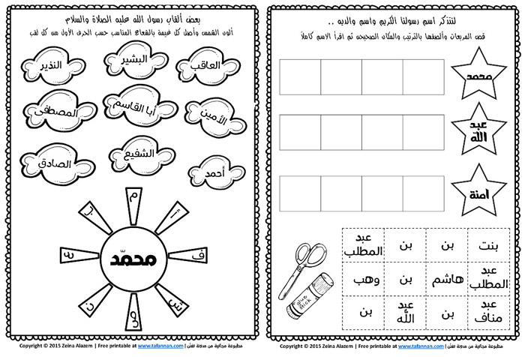](http://www.google.co.il/url?sa=i&rct=j&q=&esrc=s&frm=1&source=images&cd=&cad=rja&uact=8&ved=0ahUKEwjLofDfvtjQAhXEcBoKHQIxBnsQjRwIBw&url=http://www.tafannan.com/2015/12/blog-post_22.html&bvm=bv.140496471,bs.2,d.d2s&psig=AFQjCNFjArkSfRQAwwswHqge5bo-8Kok9g&ust=1480870524807838)

[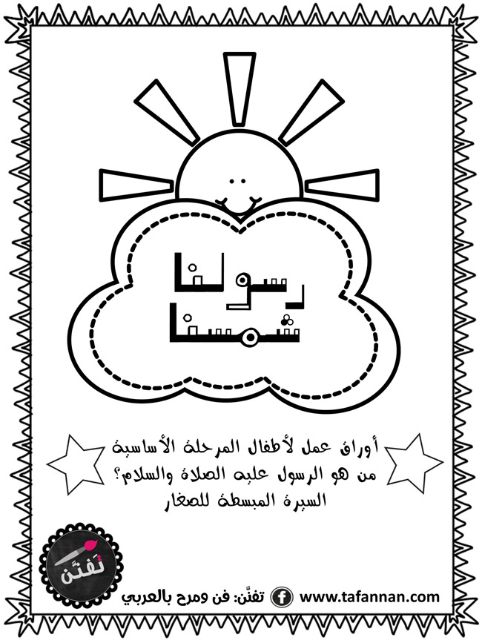](http://www.tafannan.com/2015/12/blog-post_22.html)

[](http://www.google.co.il/url?sa=i&rct=j&q=&esrc=s&frm=1&source=images&cd=&cad=rja&uact=8&ved=0ahUKEwig3bTmvtjQAhVIOxoKHTKqBL4QjRwIBw&url=http://www.tafannan.com/2015/12/blog-post_22.html&bvm=bv.140496471,bs.2,d.d2s&psig=AFQjCNFjArkSfRQAwwswHqge5bo-8Kok9g&ust=1480870524807838)