Ibn Sina School

[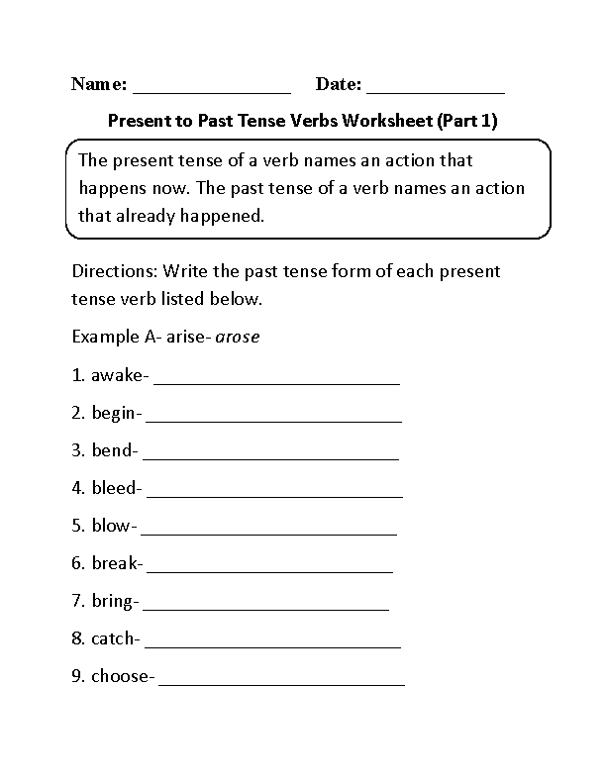](https://www.google.com/url?sa=i&url=https://www.pinterest.com/pin/510032726524673822/&psig=AOvVaw2JIt5q55VD3yvad7HAbVU-&ust=1585207543824000&source=images&cd=vfe&ved=0CAIQjRxqFwoTCNjz0LWMtegCFQAAAAAdAAAAABAV)