Ibn Sina School –Read and answer

[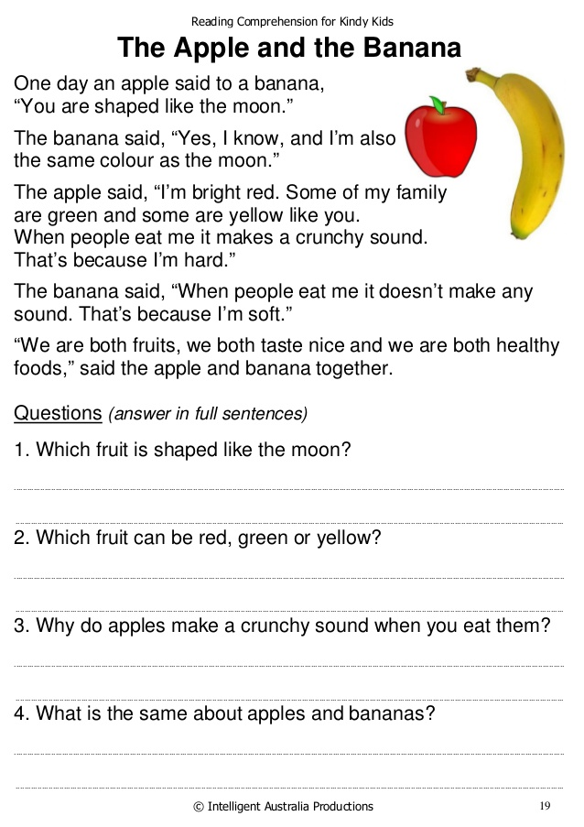](https://www.google.com/url?sa=i&url=https://fasrintl864.weebly.com/55-reading-comprehension-for-level-n4.html&psig=AOvVaw2VvYNH0nYZI1TWOrtUrFwr&ust=1584512136937000&source=images&cd=vfe&ved=0CAIQjRxqFwoTCNCd2ertoOgCFQAAAAAdAAAAABAS)