[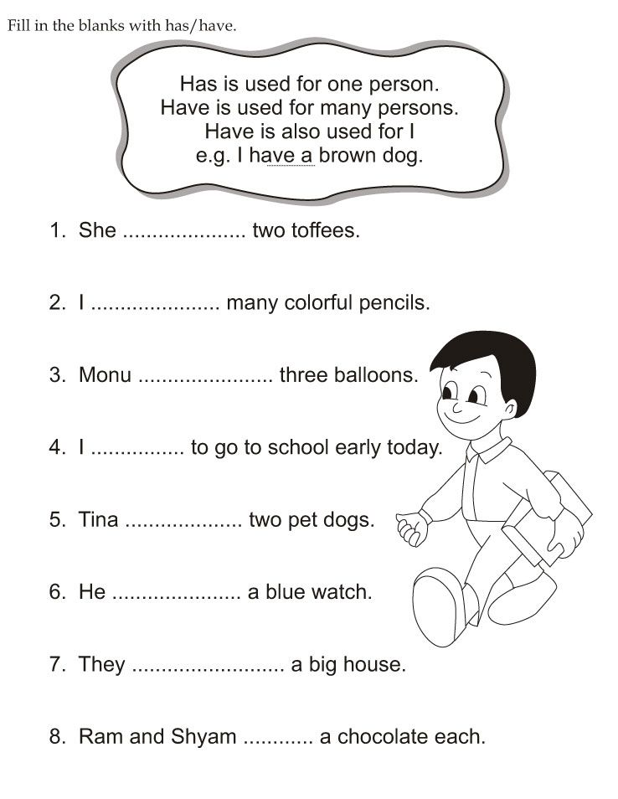](https://www.google.com/url?sa=i&rct=j&q=&esrc=s&source=images&cd=&cad=rja&uact=8&ved=2ahUKEwi0lPahhPfgAhUMyoUKHQJ2CHgQjRx6BAgBEAU&url=https://www.pinterest.com/pin/514888169872729603/&psig=AOvVaw0Ph4OrEQoByJ4dMSzX8w02&ust=1552288721552320)