**Ibn Sina School**

**6th Grades**

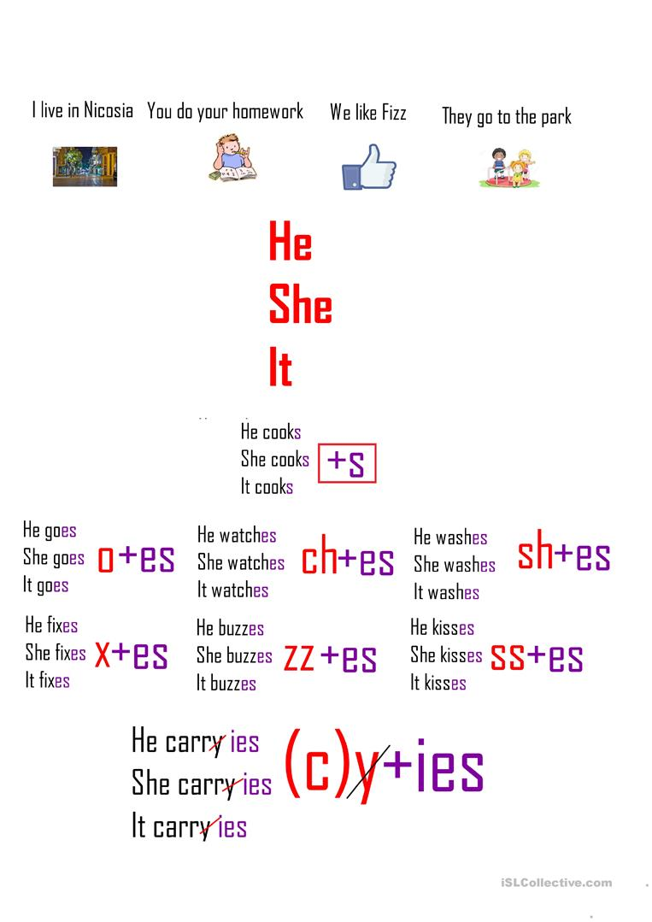

[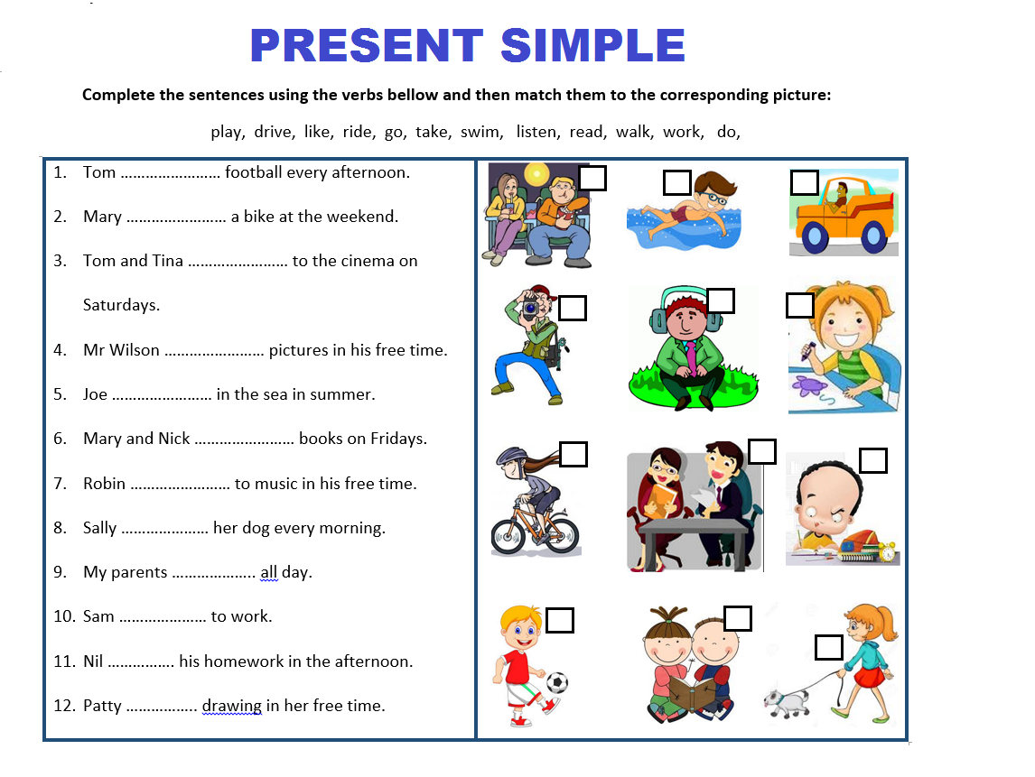](https://www.google.com/url?sa=i&url=https://www.pinterest.com/pin/457256168401773452/&psig=AOvVaw3NVJz2FZ1o4vOZdkkkRA3E&ust=1587652588645000&source=images&cd=vfe&ved=0CAIQjRxqFwoTCOjbwvig_OgCFQAAAAAdAAAAABA2)