**الحيوانات في الشتاء**

تختلف حياة الحيوانات في الشتاء , اكمل الناقص :

هناك حيوانات تدخل في سبات مثل :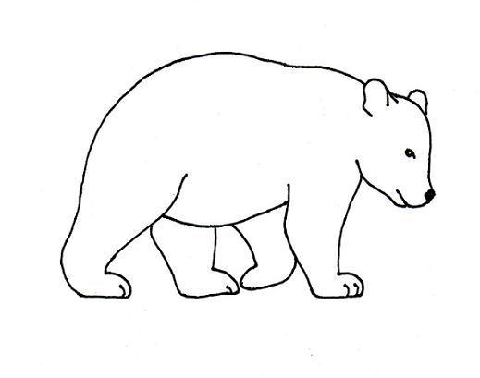

1. __________

[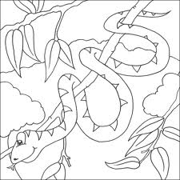](http://www.google.co.il/imgres?imgurl=http://www.onlinecoloringbookpages.com/images/snake-coloring-page-03.gif&imgrefurl=http://www.onlinecoloringbookpages.com/Snake-Coloring-Pages.php&usg=__thH9CC1TTVZgWopO-uMxk4dr5YQ=&h=553&w=553&sz=24&hl=ar&start=0&zoom=1&tbnid=k5M_RnStAJLZ6M:&tbnh=104&tbnw=104&ei=JsdcTbLSMoGcOs-bsckK&prev=/images?q=%D8%A7%D9%84%D8%A7%D9%81%D8%A7%D8%B9%D9%8A&hl=ar&sa=X&rlz=1T4ADSA_enIL418IL418&biw=1356&bih=516&gbv=2&tbs=isch:1,itp:lineart&itbs=1&iact=hc&vpx=843&vpy=79&dur=1170&hovh=225&hovw=225&tx=140&ty=105&oei=JsdcTbLSMoGcOs-bsckK&page=1&ndsp=30&ved=1t:429,r:1,s:0)

1. __________

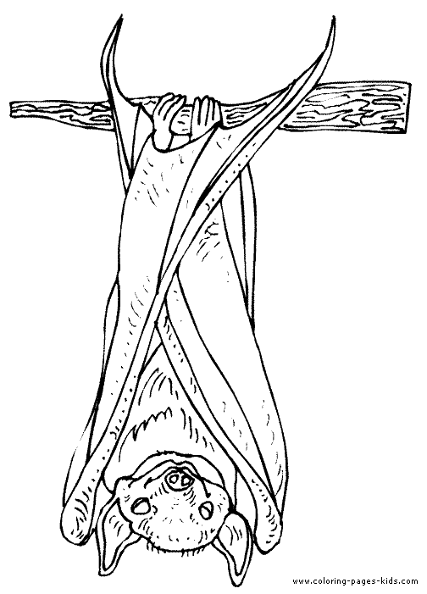

1. __________

مخزن :

الدب , الخفاش , الثعبان

هناك كائنات تنشط في الشتاء , مثل :

1. ____________ تنشط في الشتاء

[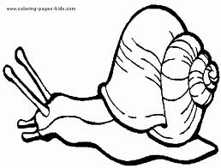](http://www.google.co.il/imgres?imgurl=http://www.coloring-pages-kids.com/coloring-pages/animal-coloring-pages/snails-coloring-pages/snails-coloring-pages-images/snail-coloring-page-02.gif&imgrefurl=http://www.coloring-pages-kids.com/coloring-pages/animal-coloring-pages/snails-coloring-pages/snails-coloring-pages-images/snail-coloring-page-02.php&usg=__xAWXrPMunGWcEor8Xhw-TEXMPv8=&h=361&w=475&sz=6&hl=ar&start=0&zoom=1&tbnid=tis9srTVbPJSvM:&tbnh=109&tbnw=143&ei=EM1cTZKbNcOhOvTi7eQK&prev=/images?q=%D8%AD%D9%84%D8%B2%D9%88%D9%86&hl=ar&sa=G&rlz=1T4ADSA_enIL418IL418&biw=1356&bih=516&gbv=2&tbs=isch:1,itp:lineart&itbs=1&iact=hc&vpx=458&vpy=253&dur=811&hovh=196&hovw=258&tx=130&ty=172&oei=EM1cTZKbNcOhOvTi7eQK&page=1&ndsp=30&ved=1t:429,r:24,s:0)

2. ___________ تنشط في الشتاء . [](http://www.google.co.il/imgres?imgurl=http://www.momsnetwork.com/kids/coloring/animals/worm1.gif&imgrefurl=http://bts-foundation.org/gu-worm-free-coloring-pages.htm&usg=__3qHS2CpkEhzEi8KzVusvy9MAd1I=&h=501&w=601&sz=13&hl=ar&start=0&zoom=1&tbnid=8VPpWSpb-mbJNM:&tbnh=111&tbnw=133&ei=Dc5cTYeFJYOUOrrf-OsK&prev=/images?q=%D8%AF%D9%88%D8%AF%D8%A9+%D8%A7%D9%84%D8%A7%D8%B1%D8%B6&hl=ar&rlz=1T4ADSA_enIL418IL418&biw=1356&bih=516&gbv=2&tbs=isch:1,itp:lineart&itbs=1&iact=hc&vpx=771&vpy=126&dur=390&hovh=205&hovw=246&tx=106&ty=100&oei=Dc5cTYeFJYOUOrrf-OsK&page=1&ndsp=31&ved=1t:429,r:22,s:0)

3._____________ ينشط في الشتاء

[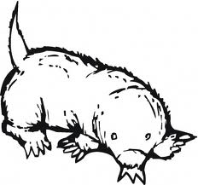](http://www.google.co.il/imgres?imgurl=http://www.supercoloring.com/wp-content/thumbnail/2009_01/mole-5-coloring-page.gif&imgrefurl=http://www.supercoloring.com/pages/mole-3/&usg=__8K91llPi5dH2JGRrGMafcbEiRpo=&h=360&w=385&sz=40&hl=ar&start=0&zoom=1&tbnid=r60Y1PBDbgAoOM:&tbnh=148&tbnw=158&ei=V85cTearEcGCOt3M4dwK&prev=/images?q=%D8%A7%D9%84%D8%AE%D9%84%D8%AF&hl=ar&rlz=1T4ADSA_enIL418IL418&biw=1356&bih=516&gbv=2&tbs=isch:1,itp:lineart&itbs=1&iact=hc&vpx=821&vpy=141&dur=16&hovh=217&hovw=232&tx=89&ty=102&oei=V85cTearEcGCOt3M4dwK&page=1&ndsp=16&ved=1t:429,r:1,s:0)

مخزن :.

الخلد, دودة الشتاء ,الحلزون