Ibn Sina School

[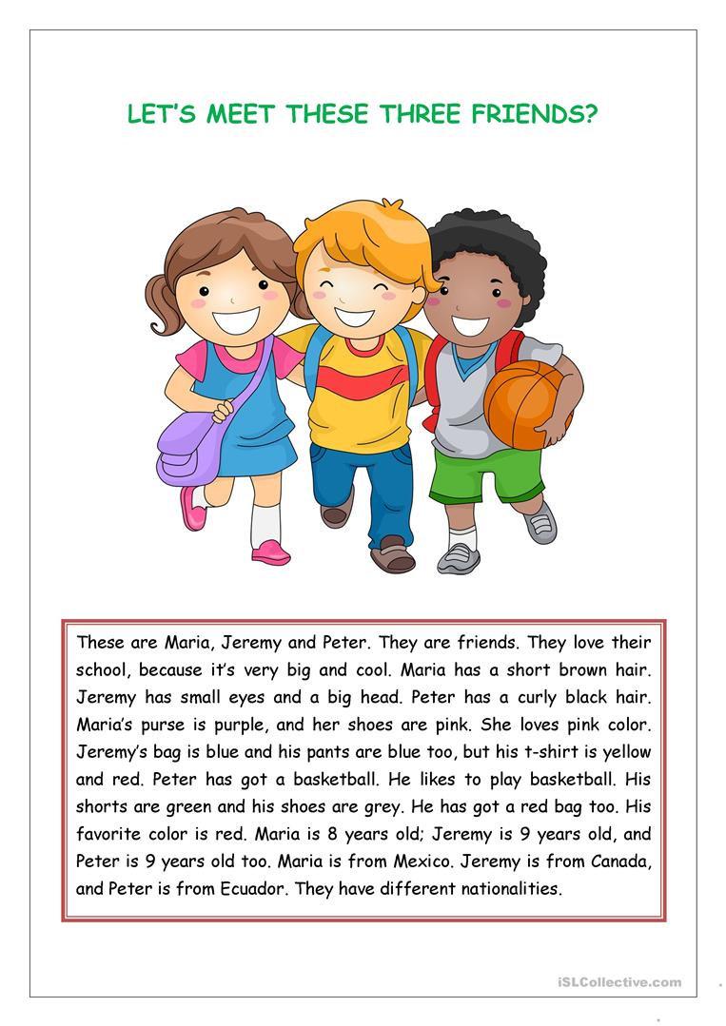](https://www.google.com/url?sa=i&url=https://en.islcollective.com/english-esl-worksheets/grammar/apostrophe-s/reading-comprehension-kids/97755&psig=AOvVaw01uE1TQ47lwegj_4Nsmusa&ust=1586154479850000&source=images&cd=vfe&ved=0CAIQjRxqFwoTCNjmkoXU0OgCFQAAAAAdAAAAABAD)

Read the text then

1-write the verbs, fin out their meaning, write their tense!

2-Write adjectives from the text!

Good Luck ND HAVE SAFE DAYS